**QUICK SORT**

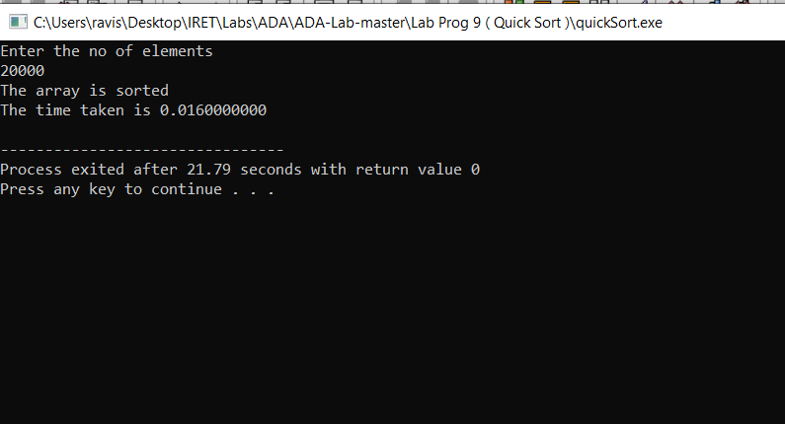

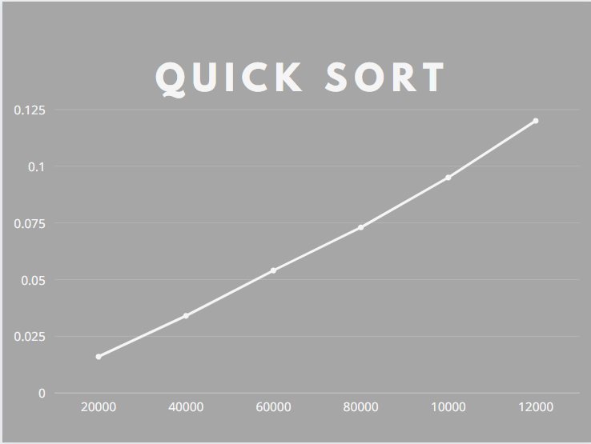

|  |  |
| --- | --- |
| Merge Sort  Array size | Time in sec |
| 20000 | 0.016 |
| 40000 | 0.034 |
| 60000 | 0.054 |
| 80000 | 0.073 |
| 100000 | 0.095 |
| 120000 | 0.120 |